CHAPTER-1
INTRODUCTION

Heading 1

1.2 Heading 2

CHAPTER-2
LITERATURE REVIEW
A literature review is a survey of scholarly sources on a specific topic. It provides an overview of current knowledge, allowing you to identify relevant theories, methods, and gaps in the existing research.

Critical Analysis of the literature
This section should be written by comparing different articles, critically assessing their content, interpreting the meaning. Do not discuss each article individually.

Implication and conclusion

Note:
- While selecting research papers for literature review it should be published between 2022 to 2024.
- Articles must be from reputed journals like IEEE Transactions, Springer, Elsevier and ACM.
- Need 10(minimum) research papers to support systematic literature review. (Mandatory)

  - Problem Statement

  - Objectives (Constraint to 2-3)

CHAPTER-3

SYSTEM DESIGN

3.1

3.2
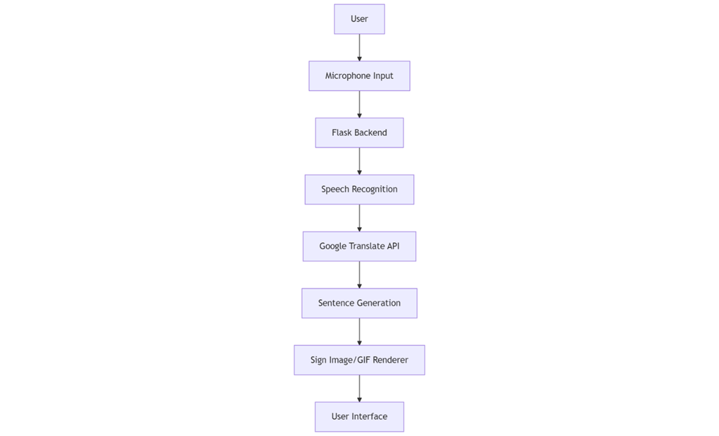
Figure 3.1: Architecture of Proposed System

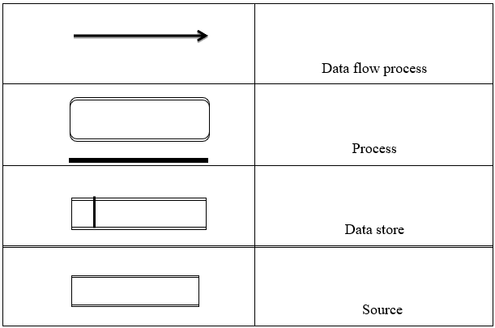
Figure 3.2: General Notation of Data Flow Diagram

CHAPTER-4
RESULTS AND DISCUSSION
Table 4.1: Test Cases
MODULE | GIVEN INPUT | EXPECTED OUTPUT | ACTUAL OUTPUT | REMARKS
Camera Initialization | Camera device connected and application started. | Live video feed is captured and displayed in the GUI window. | Camera feed displayed successfully. | Pass
Camera Initialization | No camera connected or camera busy. | Error message or fail-safe in GUI indicating no camera. | Error dialog shown (“Camera not found”). | Pass
Gesture Capture | User performs a known ISL gesture (e.g. sign for “HI”). | Hand landmarks are detected (MediaPipe outputs hand skeleton). | Hand detected, landmarks coordinates obtained. | Pass

CHAPTER-5
CONCLUSION

REFERENCES
- Muhammad Imran Saleem, Atif Siddiqui, Shaheena Noor, Miguel-Angel Luque-Nieto, Pablo Otero, "A Novel Machine Learning Based Two-Way Communication System for Deaf and Mute", Applied Sciences (Switzerland), vol. 13, no. 4, 2023. https://doi.org/10.3390/app13010453
- Bashaer A. Al Abdullah, Ghada A. Amoudi and Hanan S. Alghamdi, "Advancements in Sign Language Recognition: A Comprehensive Review and Future Prospects," in IEEE Access, vol. 12, pp. 128871-128895, 2024. http://dx.doi.org/10.1109/ACCESS.2024.3457692
- Nashat, Dalia & Shoker, Abeer & Al-Swat, Fowzyah & Al-Ebailan, Reem. (2014). AN ANDROID APPLICATION TO AID UNEDUCATED DEAF-DUMB PEOPLE. International Journal of Computer Science and Mobile Applications. 2. 2321-8363. https://www.ijcsma.com/articles/an-android-application-to-aid-uneducated-deafdumb-people.pdf

